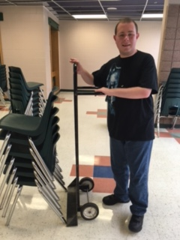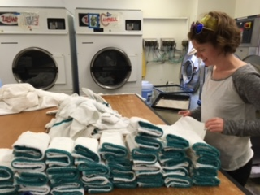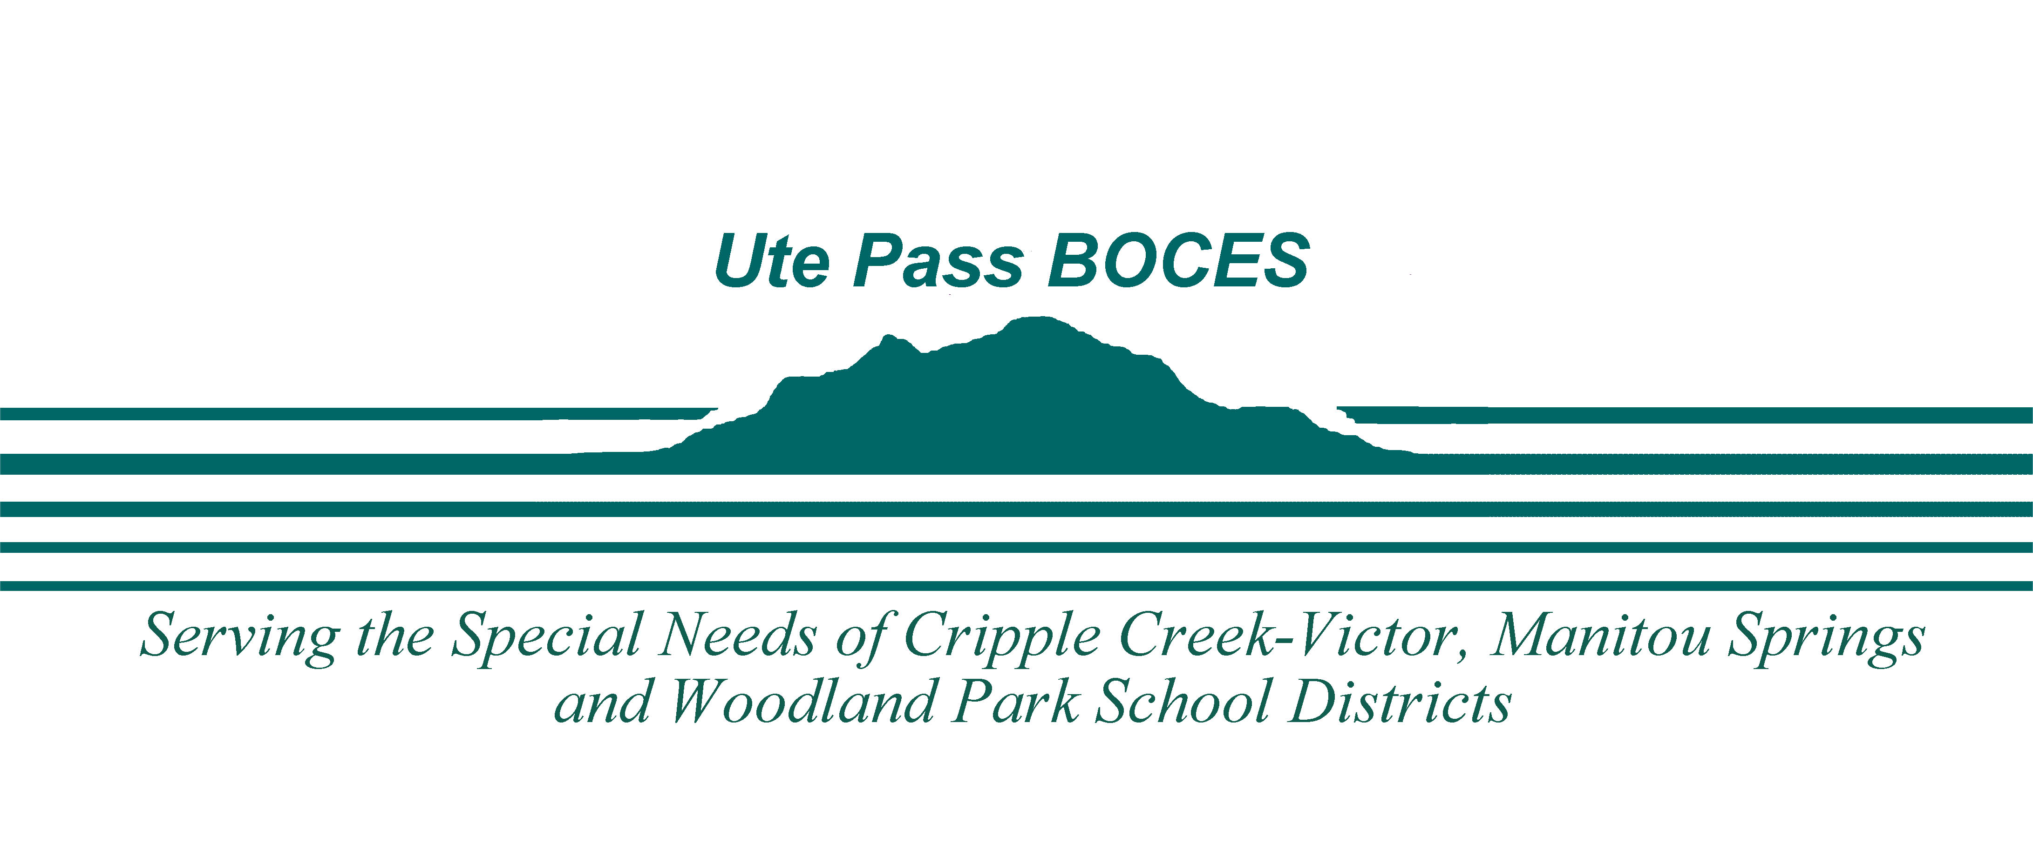

Contact Information:

Katie Ueberroth

(719) 602-9877

kueberroth@upboces.org

### Serving Manitou Springs, Woodland Park and Cripple Creek-Victor School Districts

18-21

Transition Services

Transition services is a school district community based program for students with disabilities focusing on skills and activities according to their individual needs.

**Requirements:**

* Ages18-21
* High School graduation requirements met
* Active IEP
* Continued transition needs in the areas of training, employment, education, and independent living skills

Ute Pass BOCES

**Work/Volunteer Opportunities:**

* Woodland Park Public Library
* Sweet Escapes Bakery
* Charis Bible College
* Joanie’s
* Panther Electronic Recycling Center
* Studio - Sewing and Use Clothing Store
* Teller County Animal Shelter
* Cheyenne Mountain Zoo

Te

**Transition Skills:**

-Independent Living Skills

-Employment Readiness Skills

-Vocational Training Skills

-Social and communication Skills

-Community Exploration

-Volunteer opportunities

-Leisure and recreation

-Fitness, Health and Nutrition

**Agency Connections:**

-School To Work Alliance Program

-Division of Vocational Rehabilitation

-The Resource Exchange

-The Arc of the Pikes Peak Region

-Empowering Independence

-Foundations for Successful Living

**Activities and Community Experiences:**

* Cooking
* Work Experience
* Grocery Shopping
* Basic Budgeting
* Money Handling
* Time Management
* Accessing Community Transportation
* Nutrition
* Swimming
* Fitness
* Community Exploration including Recreation and Leisure

# Activities & Community Experiences:

## Services: